AWS-Lambda Service
Amazon Web Services AWS Lambda is a serverless computing service provided by Amazon that allows developers to run code without managing servers. It automatically handles server provisioning, scaling, and maintenance, so users only need to upload their code and define when it should run.
Objectives-
- Execute Code Without Server Management-
AWS Lambda allows developers to run applications without provisioning or maintaining servers. The service handles infrastructure management automatically.
- Dynamic and Automatic Scaling-
Lambda automatically adjusts resources based on incoming traffic, whether handling a small number of requests or large-scale workloads efficiently.
- Cost-Effective Computing-
With Lambda, users pay only for the execution time consumed by their functions and the number of requests processed, reducing unnecessary infrastructure costs.
- Compatibility with Multiple Languages-
Lambda provides support for various programming languages such as Python, Node.js, Java, Ruby, .NET, and custom runtimes, enabling flexible development choices.
- Fast Function Development and Deployment-
Developers can quickly create, test, and deploy serverless functions directly through the AWS Management Console with minimal configuration effort.
Step 1- In AWS Console search AWS Lambda open lambda service click on create functions written on the orange box.
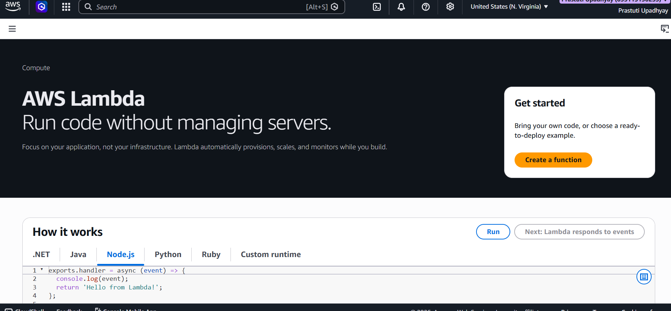
Step 2- On the Create function page, choose the Author from scratch option.
In the Basic information section, provide a suitable name for the Lambda function.
Select the required runtime environment according to the programming language you want to use, such as Python 3.14.
Keep the remaining configuration settings as default and proceed to create the function.
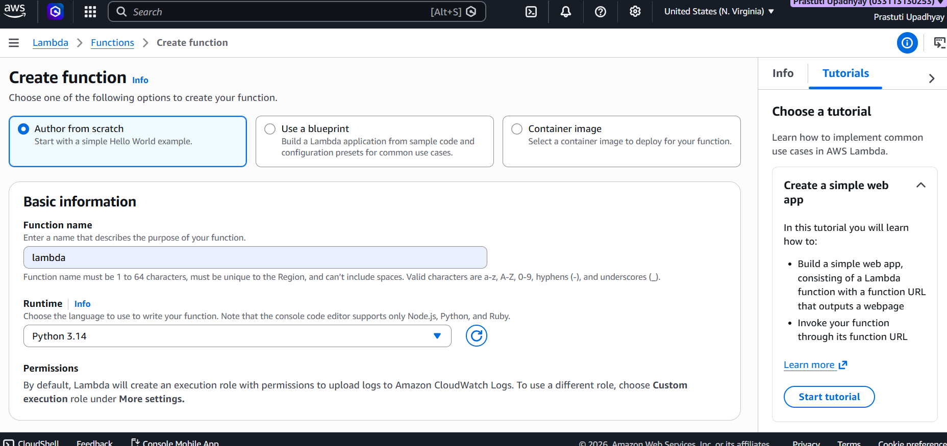
Step 3- In the Custom settings and Additional settings sections, keep the default configurations unchanged. After reviewing the settings, click the Create function button to successfully create the AWS Lambda function.
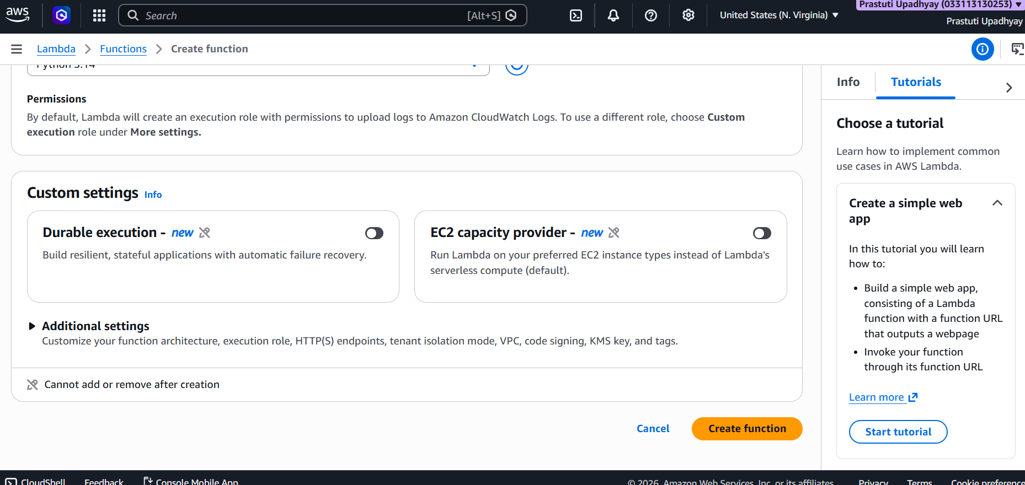
Step 4- After the function is created successfully, the Function overview page will appear.
Here, you can view the function details such as the function name, ARN, layers, and configuration
options. Navigate to the Code tab to write or edit the Lambda function code and use the Test option to execute the function.
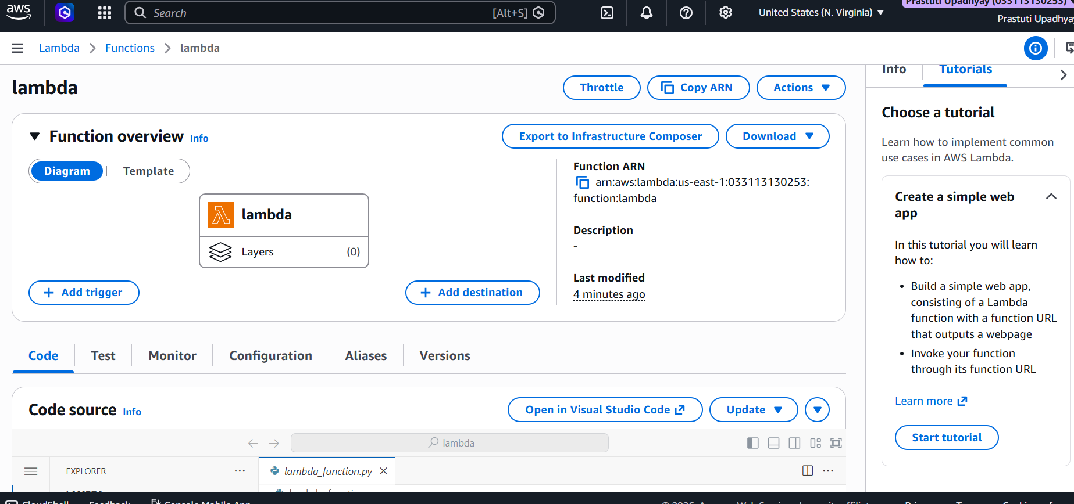
Step 5- In the Code source section, open the lambda_function.py file to view or edit the default Lambda code. Modify the function code as required for the project or assignment.
After making changes, click the Deploy button to save and deploy the updated Lambda function.
To verify the function, create a test event if needed and select the Test option to execute the code and check the output.
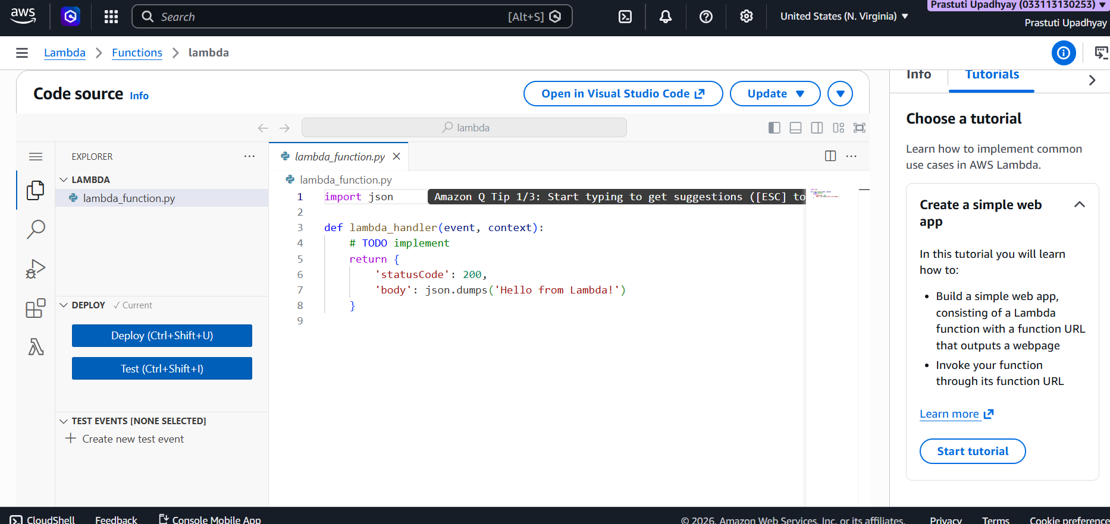
Step 6- In the Create new test event section, enter a suitable name for the test event in the Event Name field. Choose the required invocation type, such as Synchronous, to execute the function and receive an immediate response. After configuring the event details, click the Save button to store the test event successfully. The saved test event can then be used to test and verify the Lambda function execution.
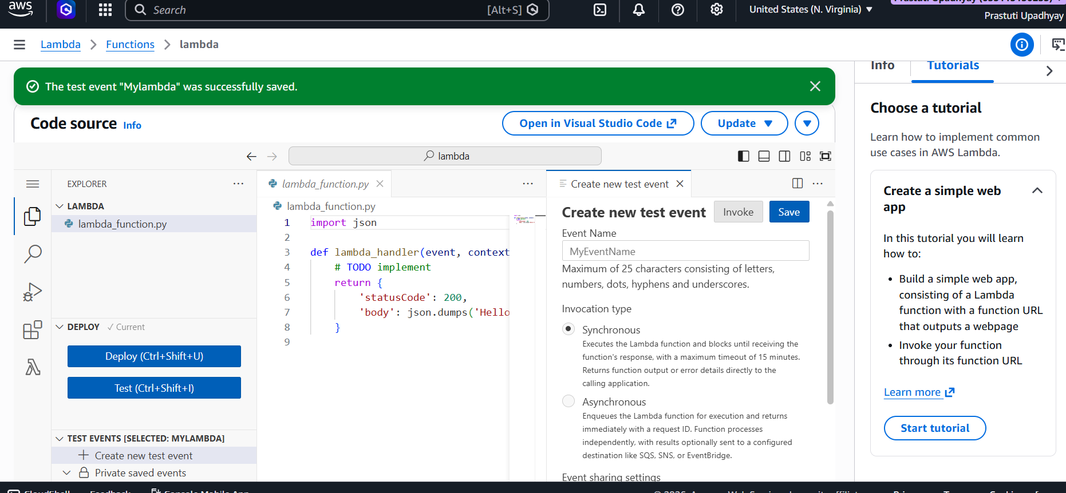
Step 7- After saving the test event, click the Test button to execute the Lambda function.
The Execution Results section will display the function status and output response generated by the code. If the execution is successful, the status will appear as Succeeded along with the returned response and status code. After verifying the output, click the Deploy button to deploy and save the latest version of the Lambda function successfully.
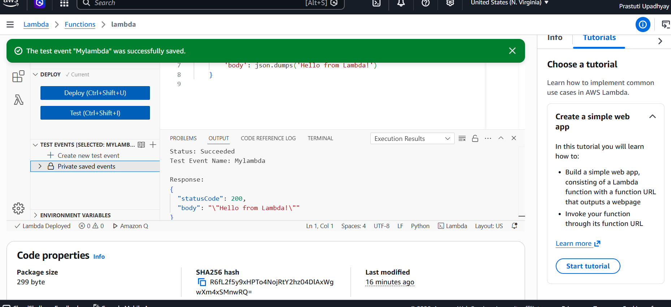
Step 8- After successful deployment and testing, return to the Functions page in AWS Lambda.
The created Lambda function will appear in the functions list along with details such as the runtime environment, package type, and last modified time. This confirms that the Lambda function has been created, deployed, and saved successfully in the AWS account.
